Due Week 4 and worth 105 points

Directions: Answer the following questions on a separate Microsoft Word or Excel document. Explain how you reached the answer or show your work if a mathematical calculation is needed, or both. Submit your assignment using the assignment link in Blackboard.

Exercises

E4-7. Kay Magill Company had the following adjusted trial balance.

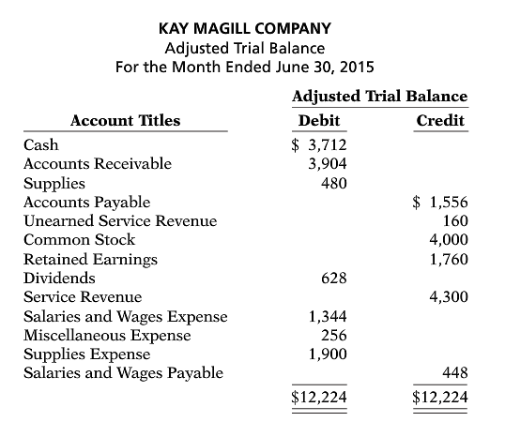

Instructions
- Prepare closing entries at June 30, 2015.
- Prepare a post-closing trial balance.

E4-13. Keenan Company has an inexperienced accountant. During the ﬁrst 2 weeks on the job, the accountant made the following errors in journalizing transactions. All entries were posted as made.
  - A payment on account of $840 to a creditor was debited to Accounts Payable $480 and credited to Cash $480.
  - The purchase of supplies on account for $560 was debited to Equipment $56 and credited to Accounts Payable $56.
  - A $500 cash dividend was debited to Salaries and Wages Expense $500 and credited to Cash $500.

Instructions
Prepare the correcting entries.

E5-4. On June 10, Tuzun Company purchased $8,000 of merchandise from Epps Company, FOB shipping point, terms 2/10, n/30. Tuzun pays the freight costs of $400 on June 11. Damaged goods totaling $300 are returned to Epps for credit on June 12. The fair value of these goods is $70. On June 19, Tuzun pays Epps Company in full, less the purchase discount. Both companies use a perpetual inventory system.

Instructions
- Prepare separate entries for each transaction on the books of Tuzun Company.
- Prepare separate entries for each transaction for Epps Company. The merchandise purchased by Tuzun on June 10 had cost Epps $4,800.

E5-7. Juan Morales Company had the following account balances at year-end: Cost of Goods Sold $60,000, Inventory $15,000, Operating Expenses $29,000, Sales Revenue $115,000, Sales Discounts $1,200, and Sales Returns and Allowances $1,700. A physical count of inventory determines that merchandise inventory on hand is $13,900.

Instructions
- Prepare the adjusting entry necessary as a result of the physical count.
- Prepare closing entries.

E6-1. Tri-State Bank and Trust is considering giving Josef Company a loan. Before doing so, management decides that further discussions with Josef’s accountant may be desirable. One area of particular concern is the inventory account, which has a year-end balance of $297,000. Discussions with the accountant reveal the following.
- Josef sold goods costing $38,000 to Sorci Company, FOB shipping point, on December 28. The goods are not expected to arrive at Sorci until January 12. The goods were not included in the physical inventory because they were not in the warehouse.
- The physical count of the inventory did not include goods costing $95,000 that were shipped to Josef FOB destination on December 27 and were still in transit at year-end.
- Josef received goods costing $22,000 on January 2. The goods were shipped FOB shipping point on December 26 by Solita Co. The goods were not included in the physical count.
- Josef sold goods costing $35,000 to Natali Co., FOB destination, on December 30. The goods were received at Natali on January 8. They were not included in Josef’s physical inventory.
- Josef received goods costing $44,000 on January 2 that were shipped FOB destination on December 29. The shipment was a rush order that was supposed to arrive December 31. This purchase was included in the ending inventory of $297,000.

Instructions
Determine the correct inventory amount on December 31.
E6-6. Kaleta Company reports the following for the month of June.
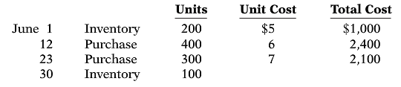
Instructions
- Compute the cost of the ending inventory and the cost of goods sold under (1) FIFO and (2) LIFO.
- Which costing method gives the higher ending inventory? Why?
- Which method results in the higher cost of goods sold? Why?

Problems

P4-3A. The completed ﬁnancial statement columns of the worksheet for Fleming Company are shown on below.
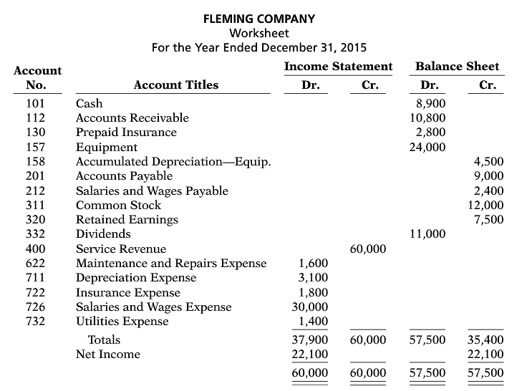

Instructions
- Prepare an income statement, a retained earnings statement, and a classiﬁed balance sheet.
- Prepare the closing entries.
- Post the closing entries and underline and balance the accounts. (Use T-accounts.) Income Summary is account No. 350.
- Prepare a post-closing trial balance.

P5-2A. Latona Hardware Store completed the following merchandising transactions in the month of May. At the beginning of May, the ledger of Latona showed Cash of $5,000 and Common Stock of $5,000.

May 1 Purchased merchandise on account from Gray’s Wholesale Supply $4,200, terms 2/10, n/30.
2 Sold merchandise on account $2,100, terms 1/10, n/30. The cost of the merchandise sold was $1,300.
5 Received credit from Gray’s Wholesale Supply for merchandise returned $300.
9 Received collections in full, less discounts, from customers billed on sales of $2,100 on May 2.
10 Paid Gray’s Wholesale Supply in full, less discount.
11 Purchased supplies for cash $400.
12 Purchased merchandise for cash $1,400.
15 Received refund for poor quality merchandise from supplier on cash purchase $150.
17 Purchased merchandise from Amland Distributors $1,300, FOB shipping point, terms 2/10, n/30.
19 Paid freight on May 17 purchase $130.
24 Sold merchandise for cash $3,200. The merchandise sold had a cost of $2,000.
25 Purchased merchandise from Horvath, Inc. $620, FOB destination, terms 2/10, n/30.
27 Paid Amland Distributors in full, less discount.
29 Made refunds to cash customers for defective merchandise $70. The returned merchandise had a fair value of $30.
31 Sold merchandise on account $1,000 terms n/30. The cost of the merchandise sold was $560.

Latona Hardware’s chart of accounts includes the following: No. 101 Cash, No. 112 Accounts Receivable, No. 120 Inventory, No. 126 Supplies, No. 201 Accounts Payable, No. 311 Common Stock, No. 401 Sales Revenue, No. 412 Sales Returns and Allowances, No. 414 Sales Discounts, and No. 505 Cost of Goods Sold.

Instructions
- Journalize the transactions using a perpetual inventory system.
- Enter the beginning cash and common stock balances and post the transactions. (Use J1 for the journal reference.)
- Prepare an income statement through gross proﬁt for the month of May 2015.
P6-3A. Ziad Company had a beginning inventory on January 1 of 150 units of Product 4-18-15 at a cost of $20 per unit. During the year, the following purchases were made.

Mar. 15 400 units at $23 Sept. 4 350 units at $26
July 20 250 units at $24 Dec. 2 100 units at $29

1,000 units were sold. Ziad Company uses a periodic inventory system.

Instructions
- Determine the cost of goods available for sale.
- Determine (1) the ending inventory, and (2) the cost of goods sold under each of the assumed cost ﬂow methods (FIFO, LIFO, and average-cost). Prove the accuracy of the cost of goods sold under the FIFO and LIFO methods.
- Which cost ﬂow method results in (1) the highest inventory amount for the balance sheet, and (2) the highest cost of goods sold for the income statement?

