STAND-ALONE PROJECT
MR637 Compensation Management

Stand-Alone Project: Compensation Consulting Project (300 points)

You should begin working on the Stand-Alone Project early in the course. Each assignment provides a benchmark for completing the Stand-Alone Project in a timely manner while working through the course. You will find this information in the “Stand-Alone Project Benchmark” section of each assignment.

For this project, you assume the role of a compensation specialist at Compensation Consulting Company (CCC). In this job, you face several challenges, and to handle each one successfully, you must draw from the material covered during this course. Specifically, you have been assigned to several client firms experiencing problems with their pay systems; these firms are relying on your expertise to assist them in correcting these problems. In each case, you generate a consulting report analyzing the compensation problems experienced by each client and formulate an action plan to correct these problems. (300 points) (A 20-page, double-spaced response is required.)
Part A | Consulting Report for Lynchburg Symphony (150 points)  The Lynchburg Symphony has a long tradition of providing their community with high-quality musical performances. The following chart lists the pay for each position in the symphony, and these fees represent the total compensation (excluding travel pay) for this year’s regular season of performances.  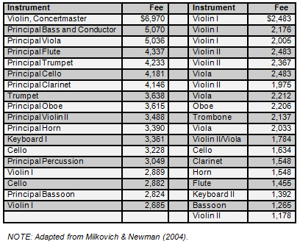  Having recently experienced problems with turnover (especially among violinists) and low morale, the symphony has seen a decline in the quality of its performances and thus in attendance. A strategic analysis concluded that the future success of the symphony will depend largely on the extent to which symphony musicians perform as a cohesive team. You have been retained by the symphony to analyze their current compensation system and provide recommendations.
 | 1. | In your report, provide an analysis of the situation. That is, using what you know about strategic and internal alignment, comment on the pay data below in light of the contextual information provided above. Based on the organization’s strategy, what should the compensation strategy look like? What kind of pay structure is being used, and what factors seem likely to account for this structure?
 | 2. | Then, describe the theories and concepts from this course that are relevant to the issues at hand.
 | 3. | Finally, apply these theories and concepts to generate sound recommendations for the symphony.
Part B | Consulting Report for Smith & Johnson Foods, Inc. (150 points)  Smith & Johnson Foods, a family-owned regional supermarket chain in the Midwest, has cultivated a strong customer base over the years by offering specialized services to their customers (e.g., drive-through parcel pickup, full-service delis and bakeries, and many other perks). Accordingly, with respect to human resources, their compensation strategy has been to attract and retain motivated and talented employees, train them extensively, and promote from within the organization. All employees (but cashiers in particular) receive extensive training and perform a number of additional duties. Cashiers receive the most additional training because they are the only employees that virtually all of the customers encounter during their store visits. This emphasis on human resources is unusual in the grocery industry, in which labor costs and training are often intentionally held down. In addition, Smith & Johnson has an annual merit raise program.  Over the past few quarters, Smith & Johnson has experienced several challenges to its otherwise strong historical performance. Turnover has increased significantly among stock clerks, produce clerks, and market clerks, in turn causing staffing and training costs to increase as well. While labor costs have been rising, productivity and sales have been falling. In addition, top management has learned that, contrary to official company policy, regional supervisors are granting across-the-board 2% merit increases to all employees. Apparently, these raises are being given to minimize conflict, so those who would otherwise receive a lower merit increase will not complain to management. Having received a copy of a recently conducted wage survey for the area, the company has forwarded the information to you. You discover that there may be additional trouble for the company because several former male employees are rumored to be considering filing a lawsuit against Smith & Johnson for unlawful pay discrimination. Apparently, the suit would charge that the cashiers (predominantly females) are paid much more than the grocery, market, and produce clerks (predominantly males). Smith & Johnson has retained your services to perform an analysis and offer recommendations. For these analyses, you will consider only full-time employees.
 | 1. | In your report, provide an analysis of the situation. That is, using what you know about external competitiveness and pay-for-performance programs, comment on the pay data below in light of the contextual information provided above. Does it appear that the organization is achieving its compensation strategy? What conclusions should we draw from the pay survey?
 | 2. | Then, describe the theories and concepts from this course that are relevant to the issues at hand.
 | 3. | Finally, apply these theories and concepts to generate sound recommendations for Smith & Johnson Foods, Inc.
 | 